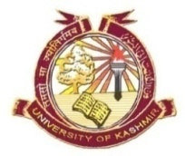
P.G. PROGRAMME IN BIORESOURCES
DEPARTMENT OF BOTANY
UNIVERSITY OF KASHMIR, SRINAGAR

Date Sheet
It is notified for the information of all the concerned that the theory examination ( Core And DCE) of M. Sc 3rd (Batch 2016) will be held as per the following schedule at Bioresources Block, University of Kashmir Srinagar.
Venue: Bioresources Block
Time: 11:00 am (except Friday)\
10:30 am Friday

M. Sc 3rd Semester
Subject Code | Course Title | Date | Day
BR15301CR | Biomolecules | 16-11-2017 | Thursday
BR15302CR | Secondary Metabolites | 20-11-2017 | Monday
BR15303CR | Biostatistics and Biotechniques | 24-11-2017 | Friday
BR15003DCE | Biological Interaction | 28-11-2017 | Tuesday

Coordinator Bioresources

No. F(Datesheet-M.Sc 3rd Sem)Biores/KU/17
Date: 20-10-2017

Copy to:
- The Controller of Examination, University of Kashmir for information.
- PRO for publication in a leading News daily.
- University Website.
- Notice Board.

